Assignment 6: (EmployeeProject_Database)

Create EmployeeDetail Table and insert records in the table as it is Mentioned in the below image and Solve questions based upon it
- Write a query to get all employee detail from "EmployeeDetail" table
Ans: Select * From EmployeeDetail;
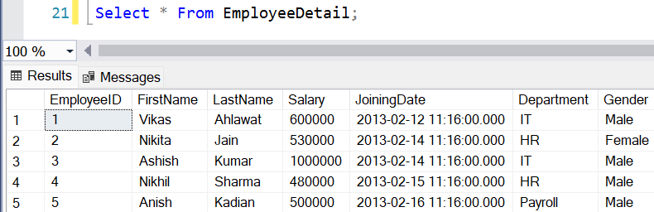

- Write a query to get only "FirstName" column from "EmployeeDetail" table
Ans: Select FirstName
From EmployeeDetail;
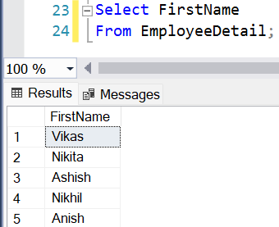

- Write a query to get FirstName in upper case as "First Name".
Ans: Select UPPER(FirstName) AS "First Name"
From EmployeeDetail;

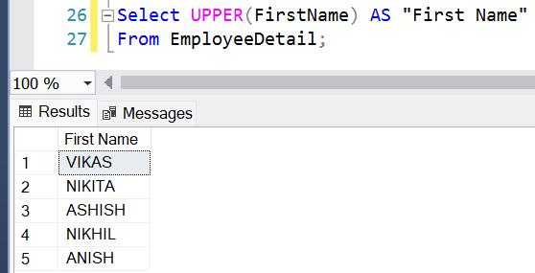

- Write a query to get FirstName in upper case as "First Name".
Ans: Select UPPER(FirstName) AS "First Name"
From EmployeeDetail;



- Write a query for combine FirstName and LastName and display it as "Name" (also include white space between first name & last name)

Ans: Select (FirstName + ' ' + LastName) AS "Name"
From EmployeeDetail;

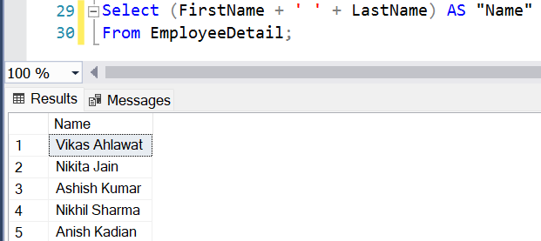

- Select employee detail whose name is "Vikas”
Ans: Select * From EmployeeDetail
Where FirstName = 'Vikas';

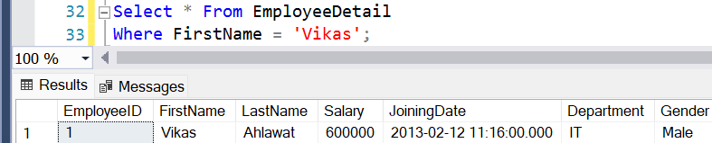

- Get all employee detail from EmployeeDetail table whose "FirstName" start with letter 'a'.
Ans: Select * From EmployeeDetail
Where FirstName Like 'A%'; 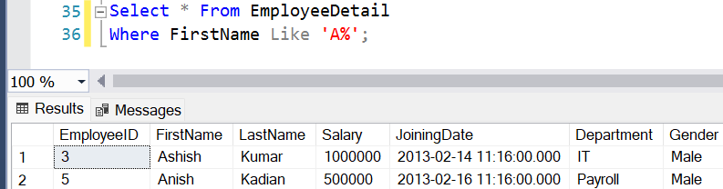

- Get all employee detail from EmployeeDetail table whose "FirstName" start with letter 'a'.
Ans: Select * From EmployeeDetail
Where FirstName Like 'A%';



- Get all employee details from EmployeeDetail table whose "FirstName" end with 'h'
Ans: Select * From EmployeeDetail
Where FirstName Like '%H';

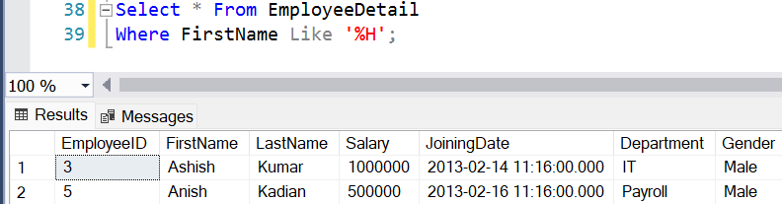

- Get all employee detail from EmployeeDetail table whose "FirstName" start with any single character between 'a-p'
Ans: Select * From EmployeeDetail
Where FirstName Like '[A-P]%';

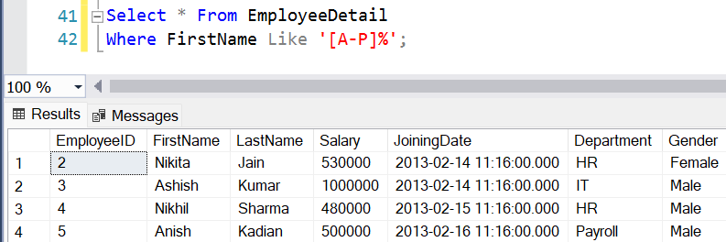

- Get all employee detail from EmployeeDetail table whose "FirstName" start with any single character between 'a-p'
Ans: Select * From EmployeeDetail
Where FirstName Like '[A-P]%';

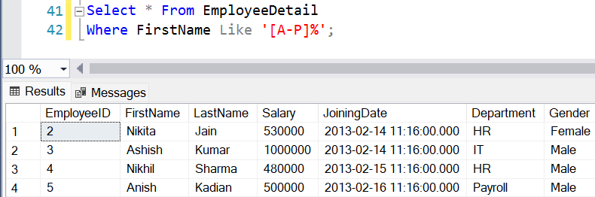

- Get all employee detail from EmployeeDetail table whose "Gender" end with 'le' and contain 4 letters. The Underscore(_) Wildcard Character represents any single character
Ans: Select * From EmployeeDetail
Where Gender Like '_le';

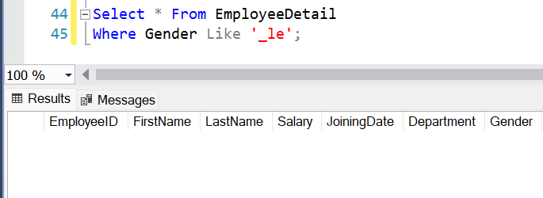

- Get all employee detail from EmployeeDetail table whose "FirstName" start with 'A' and contain 5 letters
Ans: Select * From EmployeeDetail
Where FirstName Like 'A____';

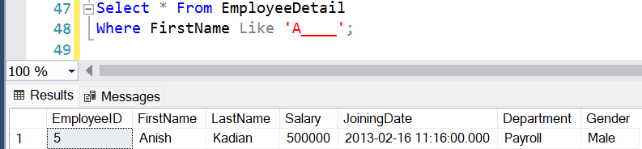

- Get all employee detail from EmployeeDetail table whose "FirstName" containing '%'. ex:-"Vik%as".
Ans: Select * From EmployeeDetail
Where FirstName Like 'Vik[%]as';

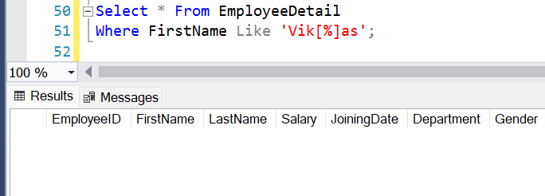

- Get all unique "Department" from EmployeeDetail table
Ans: Select Distinct Department
From EmployeeDetail;

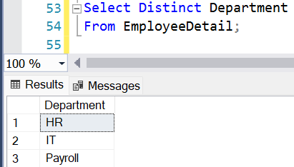

- Get the highest "Salary" from EmployeeDetail table.
Ans: Select MAX(Salary) AS HighestSalary
From EmployeeDetail;

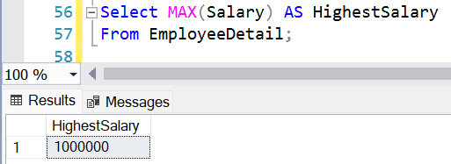

- Get the lowest "Salary" from EmployeeDetail table
Ans: Select MIN(Salary) AS LowestSalary
From EmployeeDetail;

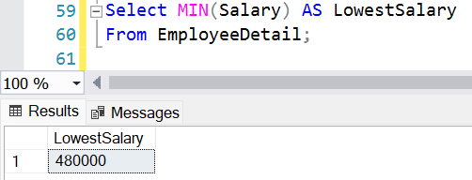

- Show "JoiningDate" in "dd mmm yyyy" format, ex- "15 Feb 2013”
Ans: Select FORMAT(CAST(JoiningDate AS DATE), 'dd-MMM-yyyy') AS JoiningDate
From EmployeeDetail;

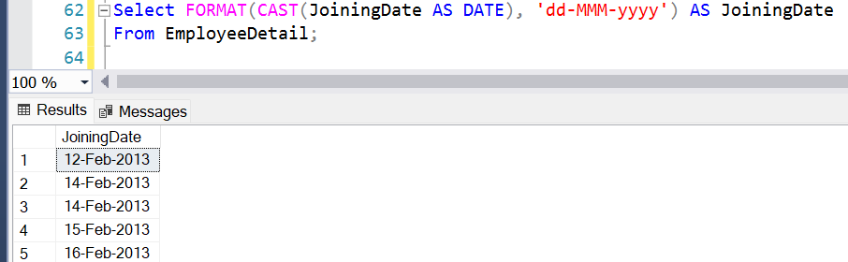

- Show "JoiningDate" in "yyyy/mm/dd" format, ex- "2013/02/15"
Ans: Select CONVERT(VARCHAR(10), JoiningDate, 23) AS JoiningDate
From EmployeeDetail;

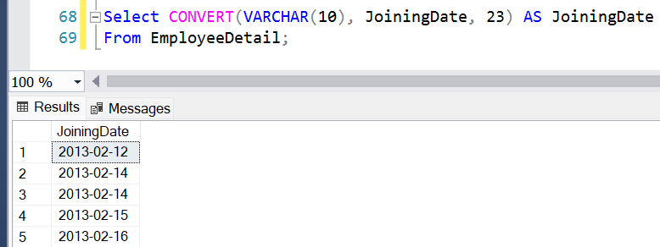

- Show only time part of the "JoiningDate"
Ans: Select LEFT(CONVERT(VARCHAR(8),CAST(JoiningDate AS Time), 108), 5) AS JoiningTime
From EmployeeDetail;

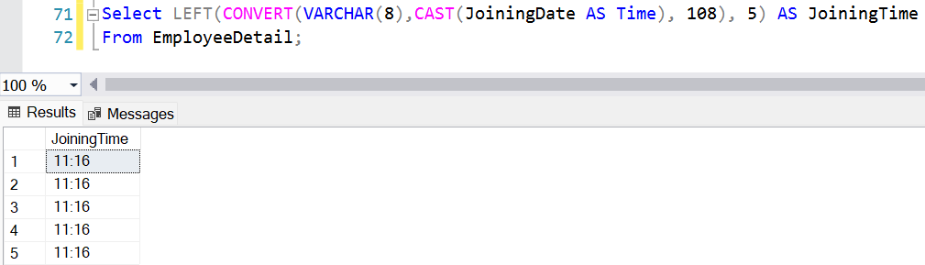

- Get only Year part of "JoiningDate"
Ans: Select YEAR(JoiningDate) AS JoiningYear
From EmployeeDetail;

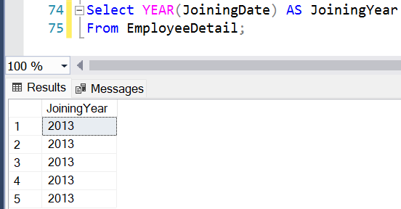

- Get only Month part of "JoiningDate”
Ans: Select MONTH(JoiningDate) AS JoiningMonth
From EmployeeDetail;

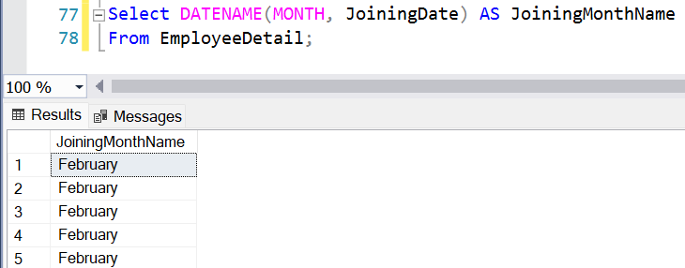

- Get system date
Ans: Select CAST(GETDATE() AS DATE) CurrentDate;

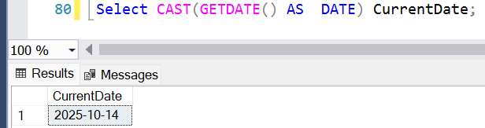

- Get UTC date.
Ans: Select GETUTCDATE() AS CurrentUTCDateTime;

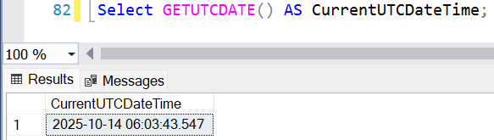

- Get the first name, current date, joiningdate and diff between current date and joining date in months.
Ans: Select FirstName,
CAST(GETDATE() AS Date) AS CurrentDate,
CAST(JoiningDate AS Date) AS JoiningDate,
DATEDIFF(Month, JoiningDate,
GETDATE()) AS MonthDifference From EmployeeDetail;

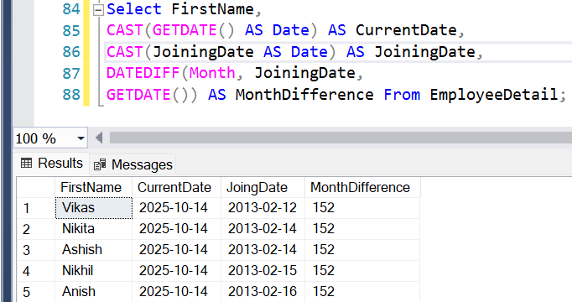

- Get the first name, current date, joiningdate and diff between current date and joining date in days.
Ans: Select FirstName,
CAST(GETDATE() AS Date) AS CurrentDate,
CAST(JoiningDate AS Date) AS JoiningDate,
DATEDIFF(DAY, JoiningDate,
GETDATE()) AS DaysDifference From EmployeeDetail;

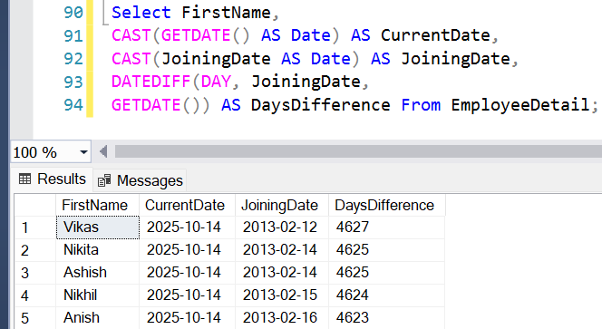

- Get all employee details from EmployeeDetail table whose joining year is 2013
Ans: Select * From EmployeeDetail
Where YEAR(JoiningDate) = 2013;

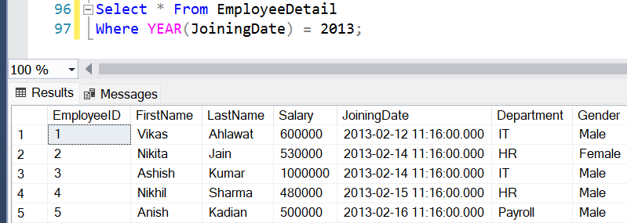

- Get all employee details from EmployeeDetail table whose joining month is Jan(1)
Ans: Select * From EmployeeDetail
Where MONTH(JoiningDate) = 1;

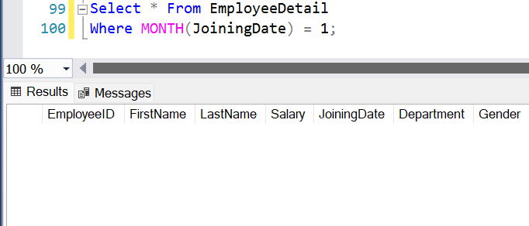

- Get all employee details from EmployeeDetail table whose joining month is Jan(1)
Ans: Select * From EmployeeDetail
Where MONTH(JoiningDate) = 1;



- Get how many employee exist in "EmployeeDetail" table
Ans: Select COUNT(*) AS TotalEmployees
From EmployeeDetail;

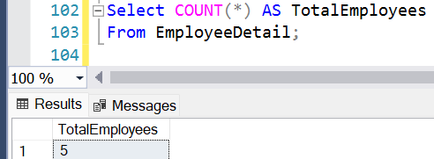

- Select only one/top 1 record from "EmployeeDetail" table
Ans: Select Top 1 *
From EmployeeDetail;

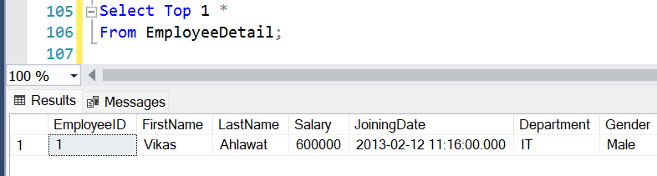

- Select all employee detail with First name "Vikas","Ashish", and "Nikhil".
Ans: Select * From EmployeeDetail
Where FirstName IN ('Vikas', 'Ashish', 'Nikhil');

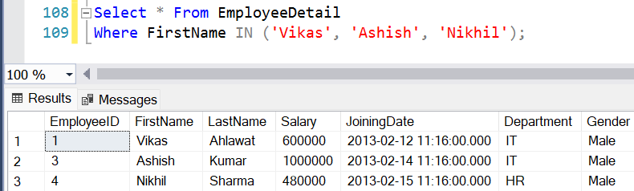

- Select all employee detail with First name not in "Vikas","Ashish", and "Nikhil"
Ans: Select * From EmployeeDetail
Where FirstName NOT IN ('Vikas', 'Ashish', 'Nikhil');

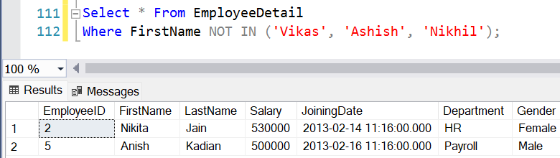

- Select first name from "EmployeeDetail" table after removing white spaces from right side.
Ans: Select RTRIM(FirstName) AS FirstName
From EmployeeDetail;

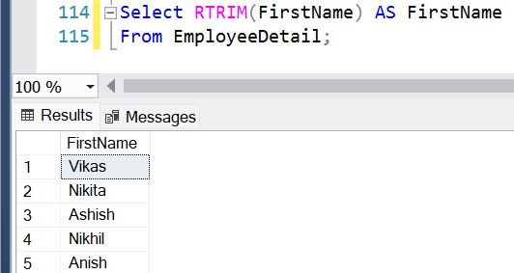

- Select first name from "EmployeeDetail" table after removing white spaces from left side.
Ans: Select LTRIM(FirstName) AS FirstName
From EmployeeDetail;

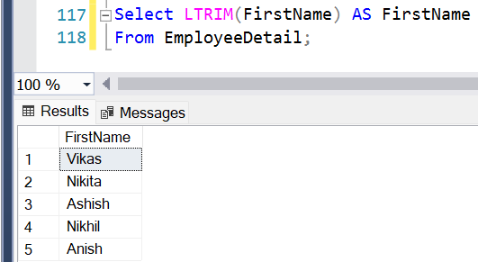

- Display first name and Gender as M/F.(if male then M, if Female then F).
Ans: Select FirstName, CASE
When Gender = 'Male' THEN 'M'
When Gender = 'Female' THEN 'F'
Else Gender
END AS Gender
From EmployeeDetail;

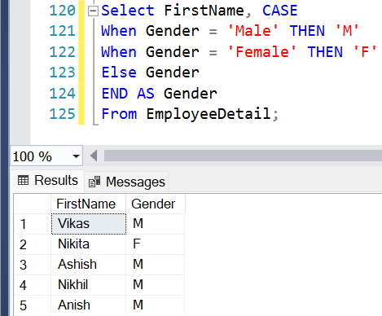

- Select first name from "EmployeeDetail" table prifixed with "Hello
Ans: Select 'Hello ' + FirstName AS Greeting
From EmployeeDetail;

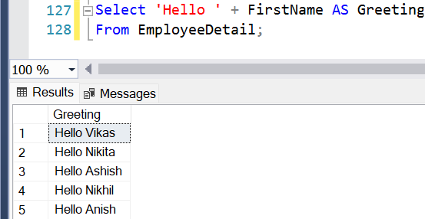

- Get employee details from "EmployeeDetail" table whose Salary greater than 600000
Ans: Select * From EmployeeDetail
Where Salary > 600000;

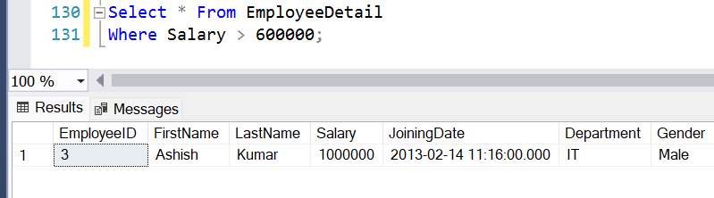

- Get employee details from "EmployeeDetail" table whose Salary less than 700000
Ans: Select * From EmployeeDetail
Where Salary < 700000;

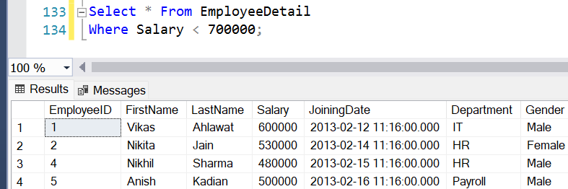

- Get employee details from "EmployeeDetail" table whose Salary between 500000 than 600000
Ans: Select * From EmployeeDetail
Where Salary BETWEEN 500000 AND 600000;

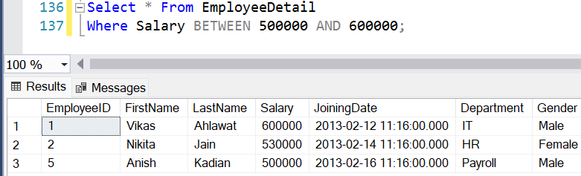

Advanced Queries(For Experienced Candidates)

Create ProjectDetail Table and insert records in the table as it is Mentioned in the below image and Solve questions based upon it

Solve the below Queries as this part is optional you can ignore also as these queries are for those who have some relevant amount of experience in SQL

- Give records of ProjectDetail table
Ans: Select * From ProjectDetail;

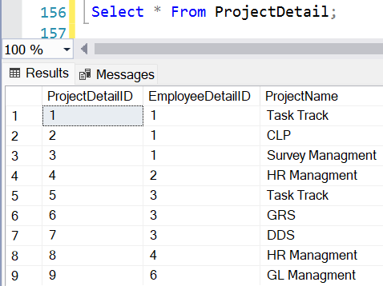

- Write the query to get the department and department wise total(sum) salary from "EmployeeDetail" table.
Ans: Select Department, SUM(Salary) AS TotalSalary
From EmployeeDetail
Group By Department;

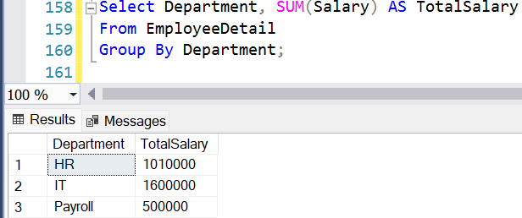

- Write the query to get the department and department wise total(sum) salary, display it in ascending order according to salary.
Ans: Select Department, SUM(Salary) AS TotalSalary
From EmployeeDetail
Group By Department
Order By TotalSalary ASC;

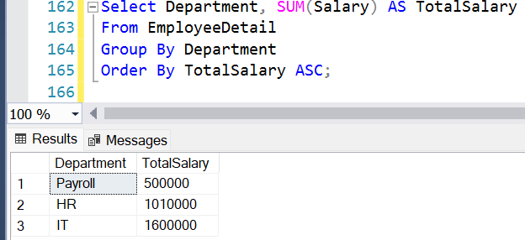

- Write the query to get the department and department wise total(sum) salary, display it in descending order according to salary
Ans: Select Department, SUM(Salary) AS TotalSalary
From EmployeeDetail
Group By Department
Order By TotalSalary DESC;

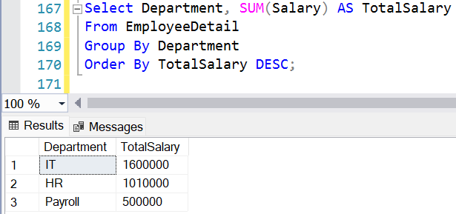
- Write the query to get the department, total no. of departments, total(sum) salary with respect to department from "EmployeeDetail" table.
Ans: Select Department,
COUNT(*) AS TotalEmployees,
SUM(Salary) AS TotalSAlary
From EmployeeDetail
Group By Department;

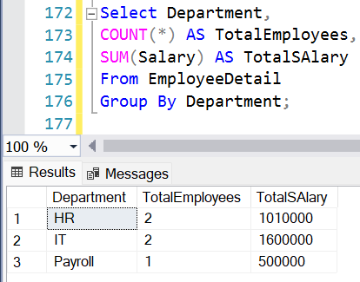

- Get department wise average salary from "EmployeeDetail" table order by salary ascending
Ans: Select Department,
AVG(Salary) AS AverageSalary
From EmployeeDetail
Group By Department
Order By AverageSalary ASC;

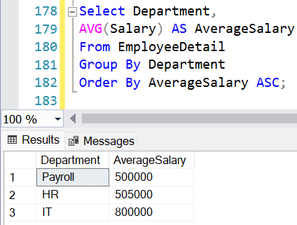

- Get department wise maximum salary from "EmployeeDetail" table order by salary ascending
Ans: Select Department,
MAX(Salary) AS MaxSalary
From EmployeeDetail
Group By Department
Order By MaxSalary ASC;

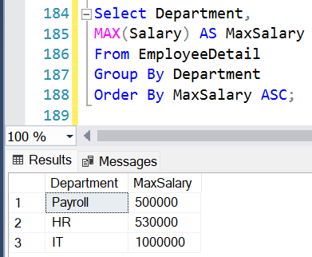

- Get department wise minimum salary from "EmployeeDetail" table order by salary ascending.
Ans: Select Department,
MIN(Salary) AS MinSalary
From EmployeeDetail
Group By Department
Order By MinSalary ASC;

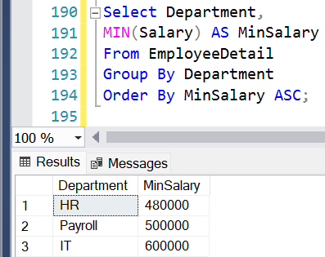

- Get department wise minimum salary from "EmployeeDetail" table order by salary ascending
Ans: Select Department,
MIN(Salary) AS MinSalary
From EmployeeDetail
Group By Department
Order By MinSalary ASC;



- Join both the table that is Employee and ProjectDetail based on some common parameter
Ans: Select
E.EmployeeID,
E.FirstName,
E.LastName,
E.Department,
E.Salary,
P.ProjectDetailID,
P.ProjectName
From EmployeeDetail E
Inner Join ProjectDetail P
ON E.EmployeeID = P.EmployeeDetailID;

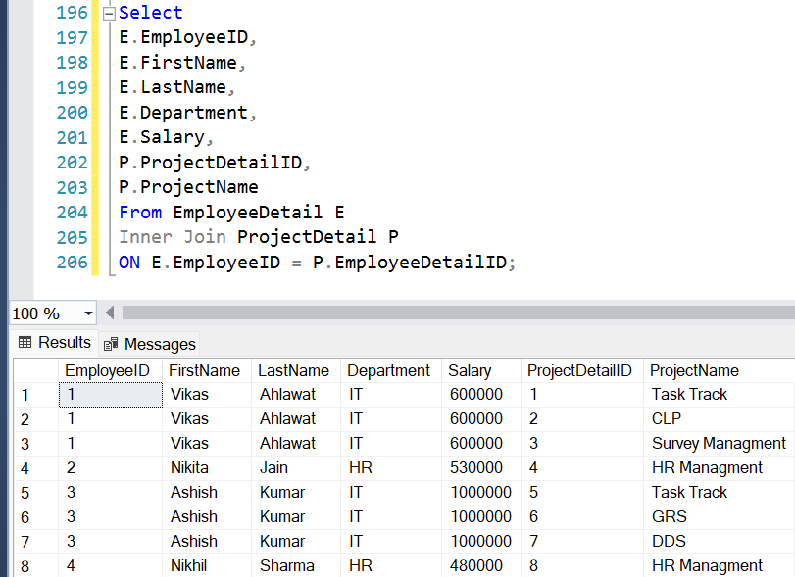

- Get employee name, project name order by firstname from "EmployeeDetail" and "ProjectDetail" for those employee which have assigned project already.
Ans: Select
E.FirstName + ' ' + E.LastName AS EmployeeName,
P.ProjectName From EmployeeDetail E
Inner Join ProjectDetail P
ON E.EmployeeID = P.EmployeeDetailID
Order By EmployeeName;

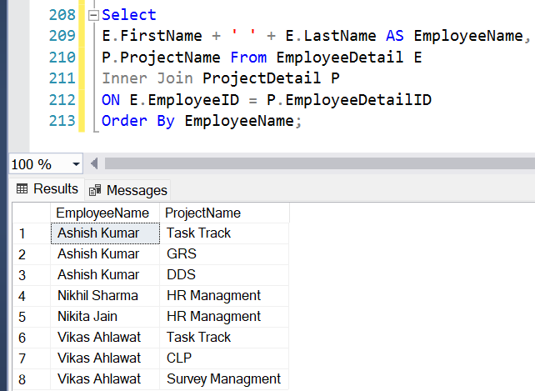

- Get employee name, project name order by firstname from "EmployeeDetail" and "ProjectDetail" for all employee even they have not assigned project.
Ans: Select
E.FirstName + ' ' + E.LastName AS EmployeeName,
P.ProjectName From EmployeeDetail E
Left Join ProjectDetail P
ON E.EmployeeID = P.EmployeeDetailID
Order By E.FirstName;

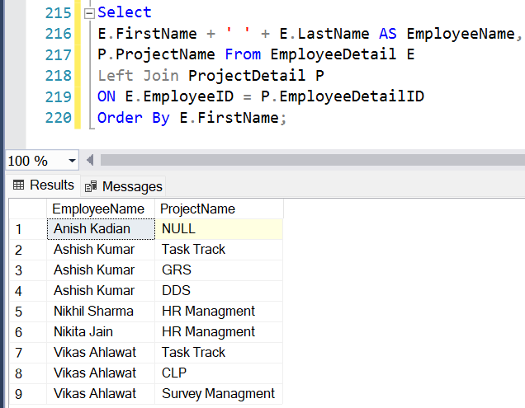

- Get employee name, project name order by firstname from "EmployeeDetail" and "ProjectDetail" for all employee if project is not assigned then display "-No Project Assigned"
Ans: Select
E.FirstName + ' ' + E.LastName AS EmployeeName,
ISNULL(P.ProjectName, 'No Project Assigned') AS ProjectName
From EmployeeDetail E
Left Join ProjectDetail P
ON E.EmployeeID = P.EmployeeDetailID
Order By E.FirstName;

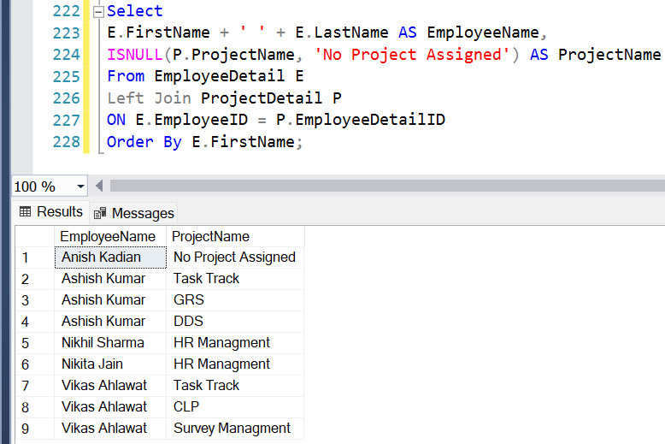

- Get all project name even they have not matching any employeeid, in left table, order by firstname from "EmployeeDetail" and "ProjectDetail
Ans: Select
E.FirstName + ' ' + E.LastName AS EmployeeName,
P.ProjectName From EmployeeDetail E
Right Join ProjectDetail P
ON E.EmployeeID = P.EmployeeDetailID
Order By E.FirstName;

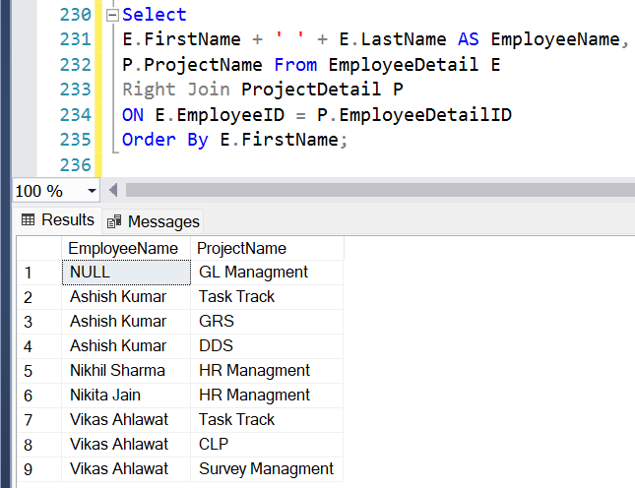

- Get complete record (employeename, project name) from both tables ([EmployeeDetail],[ProjectDetail]), if no match found in any table then show NULL
Ans: Select
E.FirstName + ' ' + E.LastName AS EmployeeName,
P.ProjectName From EmployeeDetail E
Full Outer Join ProjectDetail P
ON E.EmployeeID = P.EmployeeDetailID
Order By EmployeeName;

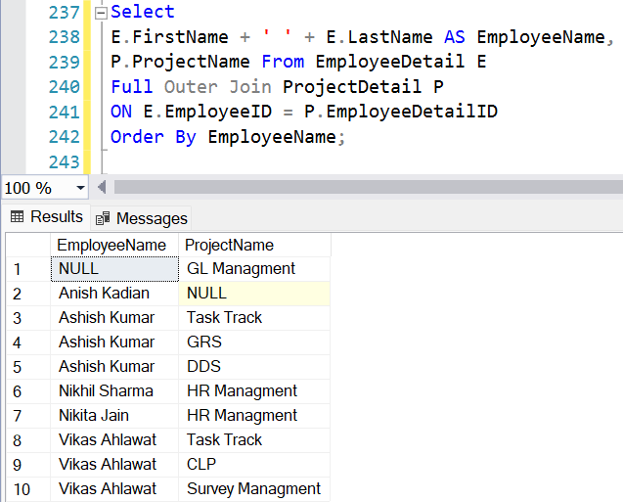
- Get complete record (employeename, project name) from both tables ([EmployeeDetail],[ProjectDetail]), if no match found in any table then show NULL
Ans: Select
E.FirstName + ' ' + E.LastName AS EmployeeName,
P.ProjectName From EmployeeDetail E
Full Outer Join ProjectDetail P
ON E.EmployeeID = P.EmployeeDetailID
Order By EmployeeName;



- Get complete record (employeename, project name) from both tables ([EmployeeDetail],[ProjectDetail]), if no match found in any table then show NULL
Ans: Select
E.FirstName + ' ' + E.LastName AS EmployeeName,
P.ProjectName From EmployeeDetail E
Full Outer Join ProjectDetail P
ON E.EmployeeID = P.EmployeeDetailID
Order By EmployeeName;



- Write down the query to fetch EmployeeName & Project who has assign more than one project
Ans: Select
E.FirstName + ' ' + E.LastName AS EmployeeName,
P.ProjectName From EmployeeDetail E
Inner Join ProjectDetail P
ON E.EmployeeID = P.EmployeeDetailID
Where P.EmployeeDetailID IN (Select
EmployeeDetailID From ProjectDetail
Group By EmployeeDetailID
Having COUNT(ProjectDetailID) > 1
)
Order By EmployeeName;

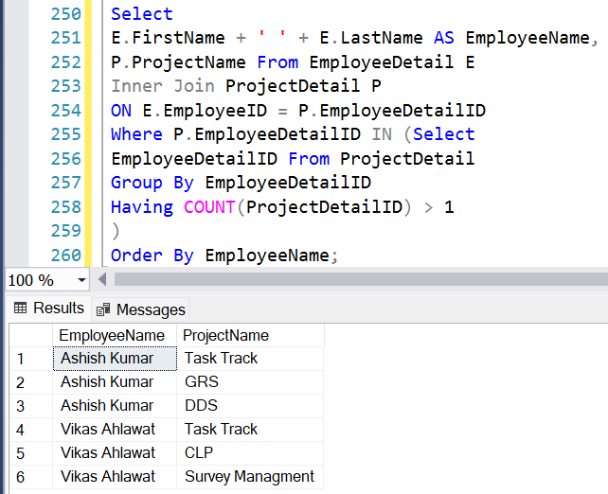

- Write down the query to fetch ProjectName on which more than one employee are working along with EmployeeName
Ans: Select
E.FirstName + ' ' + E.LastName AS EmployeeName,
P.ProjectName From ProjectDetail P
Inner Join EmployeeDetail E
ON P.EmployeeDetailID = E.EmployeeID
Where P.ProjectName IN (Select
ProjectName From ProjectDetail
Group By ProjectName
Having COUNT(DISTINCT EmployeeDetailID) > 1
)
Order By P.ProjectName, EmployeeName;

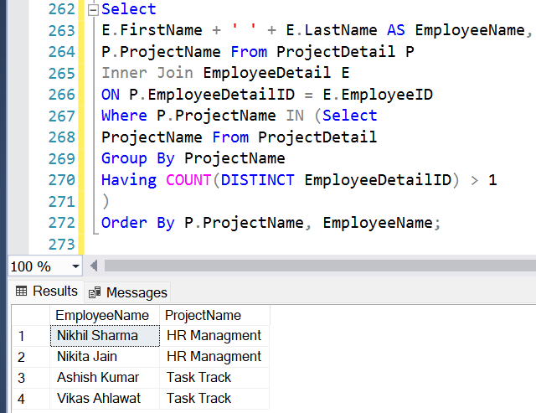

- Apply Cross Join in Both the tables
Ans: Select
E.FirstName + ' ' + E.LastName AS EmployeeName,
P.ProjectName
From EmployeeDetail E
CROSS JOIN ProjectDetail P
Order By EmployeeName, P.ProjectName;

